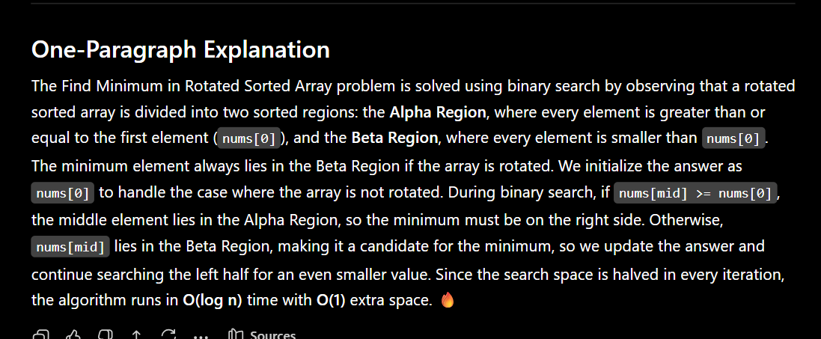
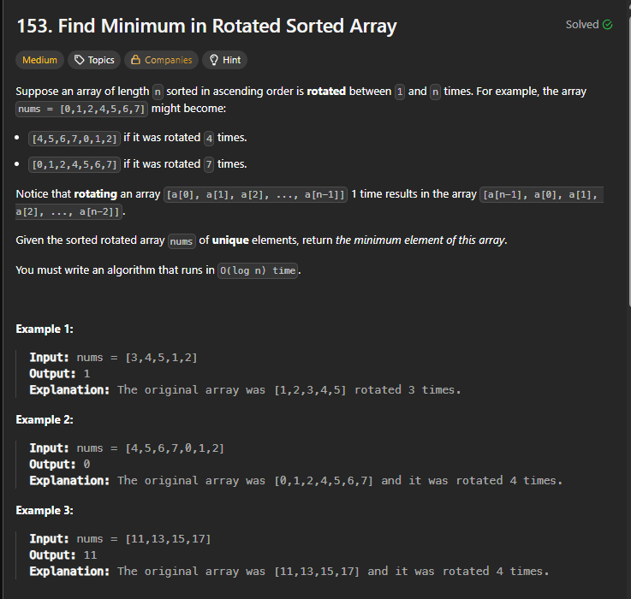

BRUTE FORCE:
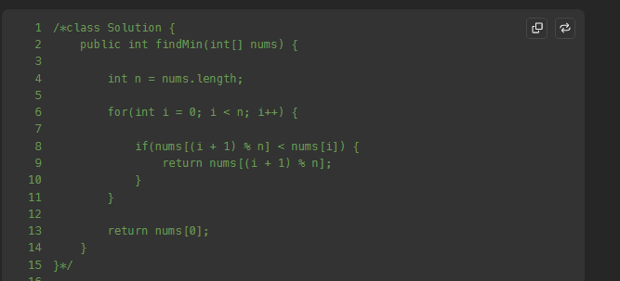

OPTIMAL:
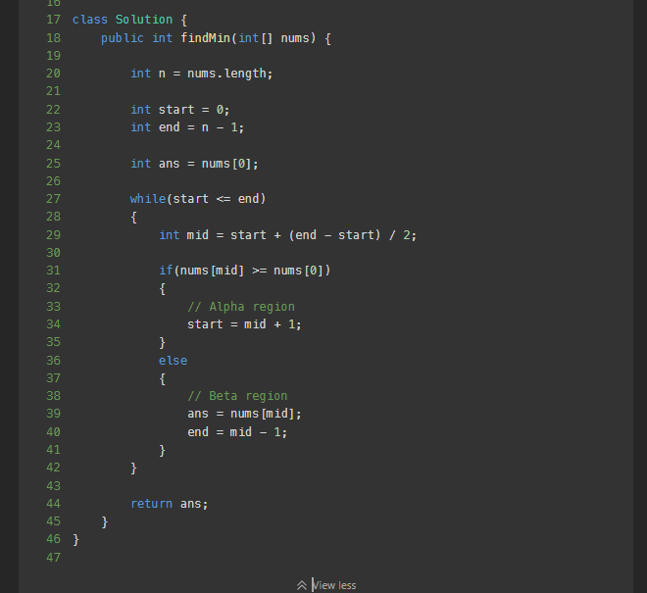

ALPHA REGION IS THE ROTAED ARRAY REGION EG IF ARRAY 567123….HERE THE 567 IS ROTATED FROM 123567 HENCE 567 IS ALPHA REGION.

